Membership Number       Membership Season

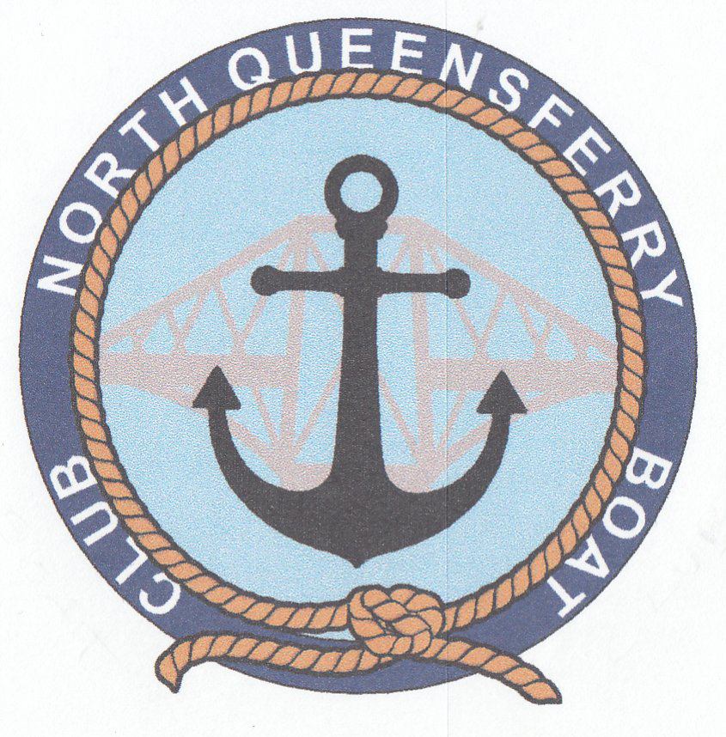

|  |  |  |  |  |  |  |  |
| --- | --- | --- | --- | --- | --- | --- | --- |
|  |  | | |  |  | Yes | No |
| Surname: |  | D of B |  |  | Mooring Required |  |  |
| Forename: |  | | |  | **Fore and Aft Mooring (Outer Bay**) |  |  |
| Street: |  | | |  | **Pontoon Mooring (Inner Bay) \*** |  |  |
| Town: |  | | |  | **Pontoon Mooring** **(Wee Bay)** |  |  |
| Post Code: |  | | |  | Storage Required ** |  |  |
| Contact No: |  | | |  | **\*Pontoon Moorings allocated only by the Committee subject to written request by boat owner (Constitution Para/Clause 11)** | | |
| E-Mail: |  | | |  | **\*\*For storage contact the Volunteer Harbour Manager of the Trust** | | |

|  |  |  |  |  |  |  |
| --- | --- | --- | --- | --- | --- | --- |
| Type of Membership | | Charge | | Tick | Comments/Notes | |
| **Ord**inary membership | | £75.00 | |  |  | |
| **F**amily | | £85.00 | |  | Add details in Family Table below | |
| **Ass**ociate | | £160.00 | |  | Add details in Association Table below | |
| **S**enior **C**itizen (65+) **-** **B**oat **O**wner | | £47.50 | |  |  | |
| **S**enior **C**itizen (65+) – **N**on **B**oat **Own**er | | £32.50 | |  |  | |
| **J**unior **-** **B**oat **O**wner (14-18Yrs) | | £45.00 | |  |  | |
| **J**unior **–** **N**on **B**oat **O**wner | | £30.00 | |  |  | |
| Honorary Membership | | £00.00 | |  |  | |
| Social Membership | | £40.00 | |  |  | |
| Additional Membership Costs | |  | |  |  | |
| Club Mooring | | £70.00 | |  |  | |
| Mooring Buoys and Ropes(New Member ) | | £60.00 | |  | Available from Mooring Team | |
| Members who do not have their own trailer and require to be Launched or Retrieved can do so by Contacting the Mooring Team. Donation may be Required | |  | |  | **Two mooring ropes @ £15 each plus £30 deposit for 2 Bouys which is refundable.** | |
| **Late Payment of Fees** (After 30th April) incurs a Penalty of £10 **Please add to Total!** | | | | | |
| Total Payable | £ | |

|  |  |  |  |  |
| --- | --- | --- | --- | --- |
| Boat Name |  |  |  | ***Insurance Company***\* |
| Make/Model |  |  |  | Name: |
| Length (m) |  |  |  | Policy NO: |
| Beam (m) |  |  |  | Date From: |
| Draft (m) |  |  |  | Date To: |
| Weight (Kg) |  |  |  | * See Page 2, T & C, Paragraph a. |

Family Table (See Notes on Page 2) Affiliate Table (See Notes on Page 2)

|  |  |  |  |  |  |
| --- | --- | --- | --- | --- | --- |
| Name | Relationship to Club Member |  | Boat Name | Club Name | Number of Members |
|  |  |  |  |  |  |
|  |  |  |  |  |  |

Please complete before Signing ***(Note: Cheques should be made Payable to North Queensferry Boat Club)***

|  |  |  |  |
| --- | --- | --- | --- |
| Cheque NO/BACS Ref | Date of Cheque/BACS | Cheque/BACS Amount | Cash Payment |
|  |  |  |  |

Fees Received. Membership Approved and Signed by

#### As a Member, I agree to the Terms and Conditions of Membership as stated on page 2

Signed:       Date:

**Equipment Register**

If you have any equipment on the hard standing (e.g. a trailer, tender or toolbox) please ensure it is marked with your membership number on it.

The info requested below will be helpful in the event of the loss or theft of your property and in the event of either, could be useful for you and the club committee, insurance company and the police in determining the rightful owner of the items listed.

|  |  |  |  |
| --- | --- | --- | --- |
| Item | Description | Marked (Boats Name or Membership Number | Other Information |
| Outboard Engine |  |  |  |
| Tender / Dinghy |  |  |  |
| Trailer(s) |  |  |  |
| Equipment / Toolbox |  |  |  |

|  |  |
| --- | --- |
| Family Membership | Affiliated Membership |
| This entitles the named member to include their immediate family (spouse/partner and children under 18 years). This does not allow family members to launch any boat. Family members like club members will have their membership terminated if their conduct is detrimental to the well being of NQFBC | This entitles the affiliated member club to elect one member to represent their club. At meetings, this representative can vote (1 Vote) on behalf of the group. This member must not be a present or past member of NQFBC, or have any conflict of interest. This membership does not allow affiliated members to launch any other boat(s) than those boat(s) listed |

##### Terms & Conditions of Membership

As a member of NQFBC and by signing the form on Page 1, I agree to:

a. Submit a copy of Insurance Policy Details (minimum Third Party Liability of Three Million Pounds) and Complete and Sign the Mooring Agreement issued by the Crown Estate.

b. Comply with NQFBC *Rules*, *Constitution*, *Harbour Regulations*, and *Crown Estate Protocols* regarding Moorings and Forth Port Authority rules regarding the operation of private pleasure craft on in-shore waters.

c. **Conduct** myself, at all times, in a manner that is **respectful** to other Members and Harbour users. Failure to do so will **affect my eligibility** for membership as stated in the **Club Constitution**.

Liability Disclaimer for use of NQFBC Equipment and Facilities

*Only members over the age of eighteen (18), and with the permission of the Club Committee, are authorised to use any mechanical and/or lifting equipment provided by the club. Any member of North Queensferry Boat Club (NQFBC) using Mini Tractor and Trailer or any other Club Equipment must assume full responsibility for any and all damages, injuries or losses that may be sustained or incurred by themselves or any other person, property or animal whether associated with the NQFBC or not*

*They must also understand that as there is a risk of associated injuries while using said equipment to themselves or others, they may be asked to certify that they are in good physical condition and have no known disabilities that might be otherwise detrimental to themselves or others well-being.*

*Members agree not to bring any claim against the organization known as NQFBC or any officer of said club should they suffer any type of injury while using or being in charge of such equipment.*

*Members agree to accept the rulings of the committee to the use and conditions and limitations on the use of said equipment.*

*Members will agree to**undertake any training**or induction course regarding any equipment that the committee designate and deem a requirement for using certain equipment, this will ensure each member will be able to use it responsibly and will comply with the requirements of the* ***Statutory Clubs Public Liability Insurance.***

***GDPR***

***As you are no doubt aware, the General Data Protection Regulation came into effect on the 25th May 2018.***

***As a valued member of the North Queensferry Boat Club your details, submitted by you on a Paper Application Form are retained/stored on an Electronic Spreadsheet as a Database and this stored information forms the basis of our contact with you.***

***The information on the database is strictly confidential and is only used by the Boat Club for its’ own administrative purposes.  The information is never sold to others.***